Assignment Chapter 11 (total 25 points)

1. Write a script that adds an index to the my_guitar_shop database for the zip code field in the addresses table. (2 points)
2. Write a script that implements the following design in a database named my_web_db:

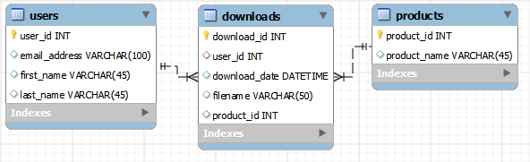

In the Downloads table, the user_id and product_id columns are the foreign keys.

Include a statement to drop the database if it already exists.

Include statements to create and select the database.

Include any indexes that you think are necessary.

Specify the utf8 character set for all tables.

Specify the InnoDB storage engine for all tables. (8 points)

1. Write a script that adds rows to the database that you created in exercise 2.

Add two rows to the Users and Products tables.

Add three rows to the Downloads table: one row for user 1 and product 2; one row for user 2 and product 1; and one row for user 2 and product 2. Use the NOW function to insert the current date and time into the download_date column. (5 points)

1. Write a SELECT statement that joins the three tables and retrieves the product_name, first_name, last_name. Sort by product_name, last_name, first_name. (3 points)
2. Write an ALTER TABLE statement that adds two new columns to the Products table created in exercise 2.

Add one column for product price that provides for three digits to the left of the decimal point and two to the right. This column should have a default value of 9.99.

Add one column for the date and time that the product was added to the database. (2 points)

1. Write an ALTER TABLE statement that modifies the Users table created in exercise 2 so the first_name column cannot store NULL values and can store a maximum of 20 characters.

Code an UPDATE statement that attempts to insert a NULL value into this column. It should fail due to the NOT NULL constraint.

Code another UPDATE statement that attempts to insert a first name that’s longer than 20 characters. It should fail. (5 points)